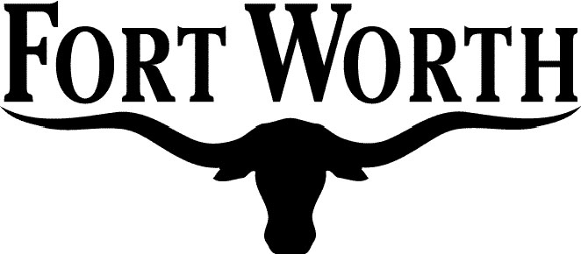

REQUEST TO SEE FINANCIAL STATEMENT
(Required by Local Government Code Section 145.007(b))

Financial Statement requested (list one only): Cary Moon

Date: 8/16/2017
Name: Fin Smith
Address: 111 West Monroe Suite 602 Phoenix, AZ, 85003
Representing: David Petersen

